iMovie (2013): Export a QuickTime file

You can export your movie as a file to use with other applications.

Create a QuickTime file

1. Select a movie, trailer, or clip in the browser.
2. Click the Share button in the toolbar, and then click File.



1. In the dialog that appears, do any of the following:
   * To set the title of the shared movie: Click the name at the top, and type a new name.
   * To set the description of the shared movie: Click in the Description field, and type new text.
   * To set tags for the shared movie: Click in the Tags field, and type tag names separated by commas.
   * To set the size of the shared movie: Choose an option from the Size pop-up menu.
   * To find out which devices will play the movie: Move the pointer over the Compatibility icon.
   * To add your movie to the Theater: Select the Add to Theater checkbox.

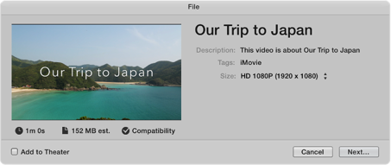

1. Click Next.
2. In the dialog that appears, type a name in the Save As field, or leave the default name, which is the name of the movie, trailer, or clip.
3. Navigate to the location where you want to save the file, and click Save.

An activity indicator appears on the right side of the toolbar. Click the activity indicator to see details. The indicator disappears when the operation has finished.

Figure. Activity indicator in the toolbar.

After the share process is complete, the movie opens in QuickTime Player. A “Share Successful” notification also appears.