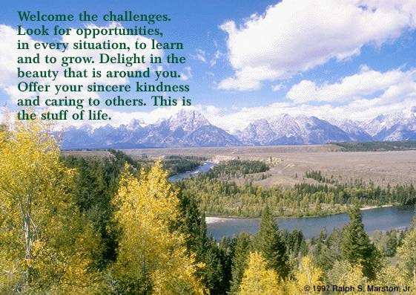

Contact information:

tracy.selekman@bsd.k12.de.us

School # 762-7146

**8th Grade Syllabus 2018-2019**

**Course Description**:

Our eighth grade services for gifted students are guided by the Parallel Curriculum Model (PCM). It has been designed to ensure that students are active participants in their learning. I use the standards, students’ connections to the world around them, students’ ability to identify with the learning that is happening, and students’ active role as a reader and writer. I look to enhance my students’ ability to read and respond to literature analytically both independently and with me and their peers. The goal is to further arm students with the tools they will need in their high school, college, and worldly experiences. We will read novels and writings from different genres and time periods in order to provide students with an opportunity to build on their reading strategies and critical thinking skills. Students will be introduced to several inquiry based learning activities in order to provide them with real-world applications of their learning. **Reading**, **writing**, **viewing**, **listening**, and **speaking** will all be key components of our course.

\***Students will also be asked to use the internet to access information and complete activities and tasks. If this presents a problem for anyone, please contact me.**

**Objectives for students**:

* Respond appropriately to a variety of texts
* Develop creative and critical approach to analyzing literature
* Comprehend and respond to various different cultures and their relation to our own by exploring the decisions and choices humans make through a variety of texts
* Demonstrate an understanding of theme and its broad applications to a variety of literary genres
* Consider the implications of literature historically and culturally
* Synthesize and evaluate information gleaned through literature in order to apply it to other works, real-world issues/events, and authentic writing
* Demonstrate a working knowledge of our language through the study of Greek and Latin root words in order to strengthen and broaden vocabulary
* Demonstrate ability to write appropriately for a variety of purposes and audiences.

**Responsibility**

My greatest goal is that students attain mastery of the concepts and ideas being taught throughout the course of the year and that they become responsible autonomous learners. In order to attain these goals, students will be held accountable for project and assignment due dates. Projects, readings, and other assignments have due dates so that students can come to class prepared to participate is class discussions and group work. All homework will be directly related to lessons and learning in the classroom. Students will be encouraged to use their agendas and e-school as tools to help them keep track of their grades and assignments.

**Communication**

I believe that communication is key when it comes to your child’s success! My website is helpful because it will contain student homework each day, and it will also display project due dates and important links for student research. Our website can be **accessed by going to P.S. duPont’s website, clicking faculty, and clicking my name.** There is a menu on the left side from which you may choose. If you ever have any questions or concerns about anything, you can call the school, but email is the quickest way to contact me. I try to check my e-mail during my planning, during lunch, and after school, and I will get back to you as soon as possible.

* Below is a list of policies for the 2017-2018 school year regarding homework and late work, and a general overview of our units for the year.

**Homework and Late Work**

**\*Homework that is due and reviewed the following day in class cannot be made up for credit.**

C:\Users\Tracy\AppData\Local\Microsoft\Windows\Temporary Internet Files\Content.IE5\6C9P8ET1\MC900441900[1].wmf

* The expectation is that students will utilize their agendas and my website so they are

accountable for their independent work and due dates.

* A failing grade (50%) will be submitted if work is not turned in.
* Students may only submit late work via e-mail if they have my consent.

What does **acceptable work** look like?

* Hard copy provided on date assignment is due
* Neat (legible hand writing or typed)
* Complete (student has followed directions and has done all components of assignment)
* Proper heading (name, date, and period number)

**Student Evaluation**:

* Class work, participation, quizzes, homework, and all other minor assignments = 30%
* Tests, quizzes, oral presentation, major projects and formal essays = 70%

**Participation**

I encourage the participation of families in their children’s studies. I highly recommend asking and engaging your children in the content that they are reading. Research demonstrates that when reading is discussed and different viewpoints are presented, the reading experience becomes more memorable and meaningful. At the beginning and end of each unit, I communicate generally what we have covered and where we are going next to keep you informed and involved.

**It takes a village…**

I am a firm believer in using as many resources as possible to make information and literature more relevant to students. Over the course of the year, I will be sending out emails requesting parents, family and/or friends to share their expertise and knowledge in order to extend our students’ experiences by coming in to speak about topics related to our units of study.

**General Overview of Units**

Below is a general list of what we will cover this year. Units will be thematic and will require students to make connections from our novels and plays to different kinds of text like non-fiction and poetry. I picked our novels/plays because I feel that they lend themselves to our umbrella themes, identity and historical context. We will read to enjoy as well as to make connections from our reading to the real world. In addition to the following units, **writing**, **grammar**, **sentence composing**, **Greek/Latin roots, and vocabulary** will be a part of our weekly schedule. (Order of units may change!)

**Community of Readers- Umbrella theme for the year: Power of the Individual**

**Unit Essential Question: What can I do to make a difference?**

* School-wide literacy book- *The Crossover*
* Analysis of an author’s use of narrative elements and figurative language
* Point of View
* Performance Tasks-Narrative Writing

**Overcoming Adversity…**

**Unit Essential Question: How do human beings overcome adversity? How can education influence our ability to transform ourselves and the world in which we live?**

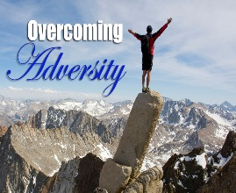

* *The Boy Who Harnessed the Wind* (autobiography)
* Bloom’s Taxonomy of Questioning (analyze, synthesize, and evaluate)
* Writing/speaking and listening
* Genre
* Whole and small group discussions regarding questions from summer

**Dabbling in Expression… Short stories and poetry will tie into each unit**

**Mini-Unit Essential Question:** **How does the poet/author utilize structure, figurative language, and perspective to covey his/her message?**

* Narrative elements

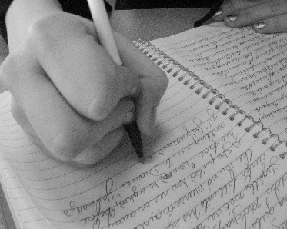

[This Photo](http://lauraberry.wordpress.com/2008/07/02/journal-vs-diary/) by Unknown Author is licensed under [CC BY-SA](https://creativecommons.org/licenses/by-sa/3.0/)

* Figurative language
* Literary devices
* Writing: Submission for writing contest (poems, short stories, non-ficition)

**With knowledge comes responsibility…**

**Unit Essential Question: What responsibilities do we have when we have knowledge? How does critical analysis of historical context help us to understand tone and author’s purpose?**

* *Frankenstein* by Robert Louis Stevenson
* Character development
* Historical context
* Debate
* Tone/Mood
* Writing Focus: Informative Common Writing Assessment and Journals

**Reading with a Critical Eye…(This unit will be combined with the next)**

**Mini-Unit Essential Question: How can I determine an author’s intent and credibility?**

* Analysis of Text Structure

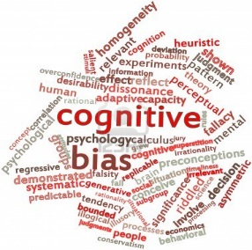

[This Photo](http://thecollaboratory.wikidot.com/philosophy-of-thought-and-logic-2014-fall) by Unknown Author is licensed under [CC BY-SA](https://creativecommons.org/licenses/by-sa/3.0/)

* Objectivity vs. Subjectivity (Bias/slant)
* Rhetoric (Logos, Ethos, Pathos)
* Writing Focus: Argumentative

**Discovering Ourselves …**

**Unit Essential Question: How can evaluating a character’s choices and decisions help us to make connections in our own lives?**

* *Flowers for Algernon* by Daniel Keyes
* Pseudo-Independent reading with whole groups discussions once per week
* Analysis and Synthesis
* Informational text regarding historical background
* Writing Focus: Text-based responses

**Meaningful Research*…***

**Unit Essential Question: How do good readers and writers use the research process to find and share information?**

* ****Independent research throughout the course of the year
* Library work
* Sources/In- text citations (MLA and APA formatting)
* Writing Focus: Informative
* Oral presentations of findings

**Utopia…**

**Unit Essential Question: How is the central idea or theme developed over the course of this novella? How does recognizing historical context affect our understanding of the text?**

* *Animal Farm*
* Various philosophies regarding the idea of utopia
* ****Socialism, Stalinism, Communism, Marxism, and Fascism
* The power of words and various genres to convey values
* Writing Focus: Argumentative writing

**Appearances May Be Deceiving…**

**Unit Essential Question: Why is Shakespeare’s writing still so relevant in our society?**

* Historical Context



[This Photo](http://barbarapicci.com/2012/05/07/ipse-dixit-william-shakespeare/) by Unknown Author is licensed under [CC BY-NC-ND](https://creativecommons.org/licenses/by-nc-nd/3.0/)

* Shakespeare Sonnets
* Shakespeare Play
* Focus: verbal communication and interpretation

In addition, students will be participating in a year-long project called The Power of the Individual. They will be selecting and researching a cause that they feel strongly about in order to create awareness and to support a corresponding organization. We will be working on this project throughout the year.

This syllabus is a general guide for the year. The order of the units may change or be combined throughout the course of the year. I use the Common Core State Standards to guide my instruction so that student learning can become more holistic and meaningful.

**Anchor Texts (we will also use many supplemental texts with the anchor texts)**

*The Boy Who Harnessed the Wind*

*The Crossover*

*Frankenstein*

“Flowers for Algernon” and other short stories

*Animal Farm*

Shakespeare play

Self-selected reading (three additional books)